Odoo Administration – User Accounts

Contents

Managing User Accounts 1

LDAP Enabled Odoo 1

Default User Permissions 1

Managing Internal Users 1

Creating Internal Users 1

Deactivating Internal Users 1

# Managing User Accounts

Odoo provides the option to add additional users at any given point.

There are three types of users in Odoo:

* **Internal**: Internal users are the paid licensed system users, which are associated with the employee records in the system and having access to do some operations (CRUD) in back end. E.g. Any company could have some departments like, Sales department, Purchase department, HR Department etc. So, for each department’s user they can give login access to do their job.
* **External**: External user is a Portal user. The user who is associated with customer record in system, which can be authorized to have read access of own transactions in the system if Odoo’s portal is used.
* **Public**: The user which does not has the login access but can read the info published on the website, is public user.

# LDAP Enabled Odoo

With the Odoo LDAP module, users can authenticate with Odoo using their Active Directory login credentials.

**NEED MORE INFORMATION HERE**

# Default User Permissions

Odoo can have basic default permissions set for new users. This can be useful when setting up new accounts to make sure everyone has the basic permissions to login.

This function needs to be enabled in **Setting > General Settings > Access Rights**. When enabled a disabled account will be created and will be used as reference by the system whenever a new account is created.

To change the default user account permissions, go to the same area in settings and click the ‘**Default Access Rights**’ link to modify the account.

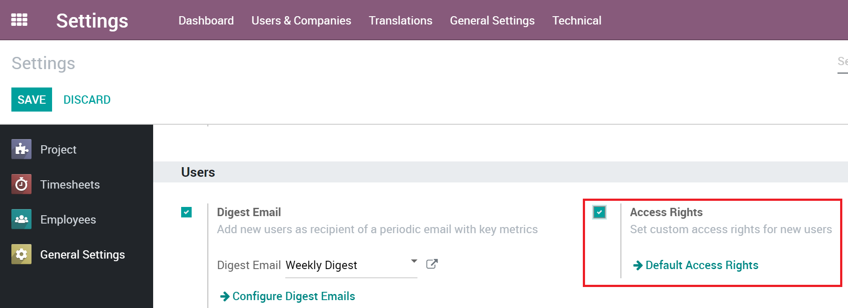

# Managing Internal Users

## Creating Internal Users

Users with the proper permissions can create and deactivate internal users.

* From the **Settings** module, go to the submenu **Users ‣ Users**
* Click on **CREATE**.
* Enter the name of the new user and their email address - the one he will use to log into Odoo instance - and a picture.

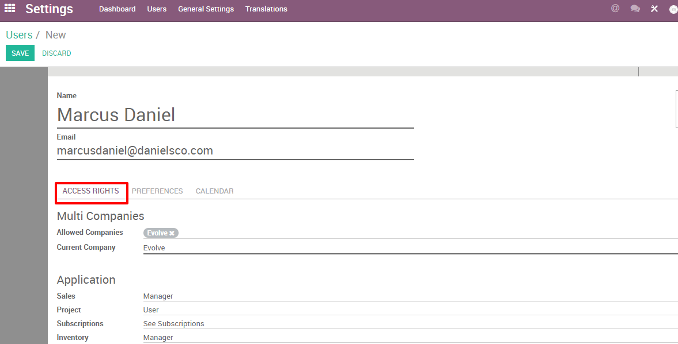

* Under **Access Rights**, choose which applications the user can access and use. Different levels of rights are available depending on the app.
* When done editing the page and have clicked on **SAVE**, an invitation email will automatically be sent to the user. The user must click on it to accept the invitation to your instance and create a log-in.

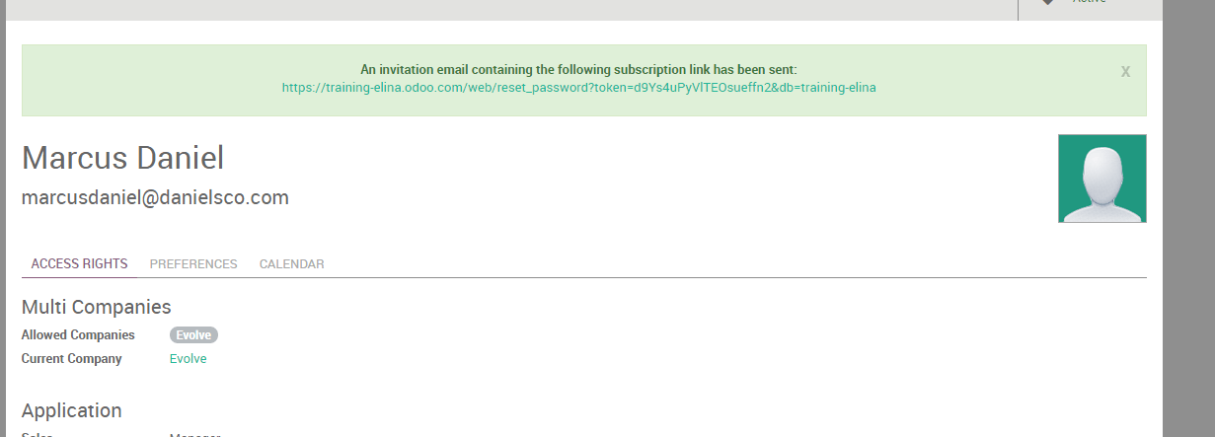

**Note:** Remember that each additional user will increase your subscription fees. Refer to the [*Pricing page*](https://www.odoo.com/pricing) for more information.

**Tip**: You can also add a new user on the fly from your dashboard. From the above screenshot, enter the email address of the user you would like to add and click on **INVITE**. The user will receive an email invite containing a link to set his password. You will then be able to define his accesses rights under the **Settings ‣ Users** menu.

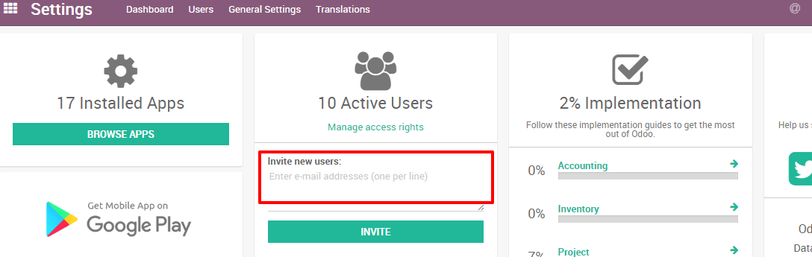

## Deactivating Internal Users

**Note:** Make sure you have enough **administrative rights** if you want to change the status of any of your users.

* In your Odoo instance, click on **Settings**.

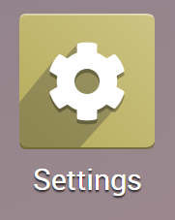

* You will have a section showing you the active users on your database. Click on **Manage access rights** or go to **Users > Users**

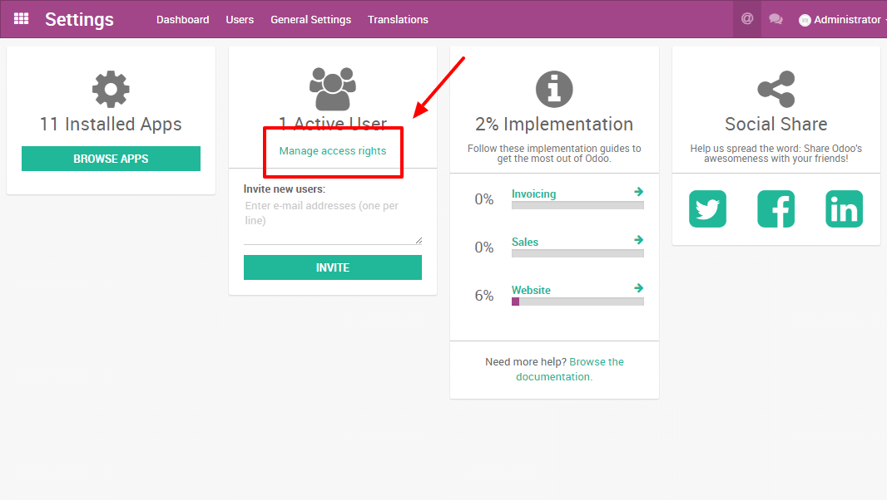

* You'll then see the list of your users.

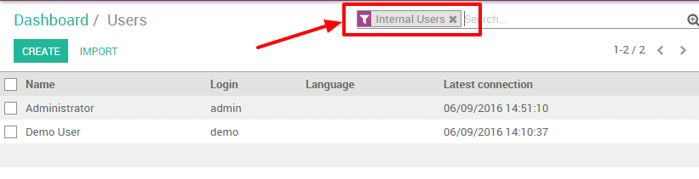

**Note**: The pre-selected filter Internal Users shows your paying users (different from the Portal Users which are free). If you remove this filter, you'll get all your users (the ones you pay for and the portal ones)

* In your list of users, click on the user you want to deactivate. As soon as you are on the user form, go with your mouse cursor on the status **Active** (top right). Click on Active and you will notice that the status will change to **Inactive** immediately.



* The user is now deactivated.

**Danger: Never** deactivate the main user (admin)